**Lab #8&9 Questions: Name: _Mengyang Cao____**

**1. Give the text for the DL file ‘alba’ below.**

dl n=4, format=fullmatrix

labels:

A,B,C,D

data:

0 1 1 0

1 0 0 1

0 0 0 0

0 0 1 0

**2a. Write out the matrix, ‘alba 2’.**

A B C D

A 1 0 0 1

B 0 1 2 0

C 0 0 0 0

D 0 0 0 0

**2b. By *how many* paths of length 2 can person 3 *get advice from* person 4?**

0, as shown in Row 3, Column 4 in the adjacent matrix squared.

**3. By *how many* paths of length 3 can person 1 *get advice from* person 3?**

2, as shown in Row 1, Column 3 in the adjacent matrix cubed.

**4. Draw the paths between the four actors (using dots and arrows), as instructed in Step 5. Is your drawing compatible with the number of ‘length 2’ paths shown in ‘alba2’?**

It is compatible to the squared matrix.

4

2

1

3

**Part B) Cognitive Maps**

**5. Print out the pooled network from Step 4. What does this network represent (*describe in detail*)?**

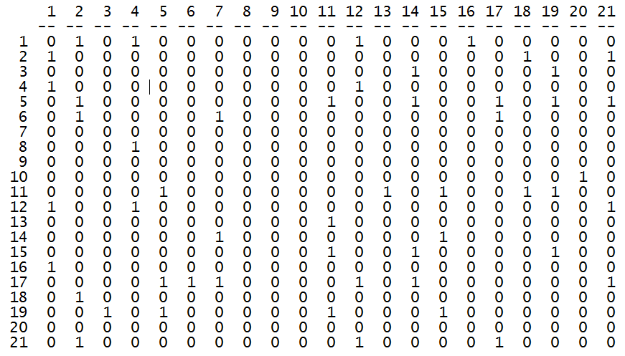

This network represents the actual friendship network created based on the each actor’s perceived network by using the interaction LAS method, which defined a friendship link as existing only when both parties agreed that it existed.

**6. What are the QAP Pearson Correlation estimates of the pooled friendship matrix with the cognitive friendship maps of Actor #20 and Actor #5, respectively?**

Actor #20: 0.085; Actor # 5: 0.504.

**7. Print out the sociograms (i.e., network diagrams) for the pooled matrix, Actor #20’s matrix, and Actor #5’s matrix. [Also bring these diagrams to class.]**

Pooled:

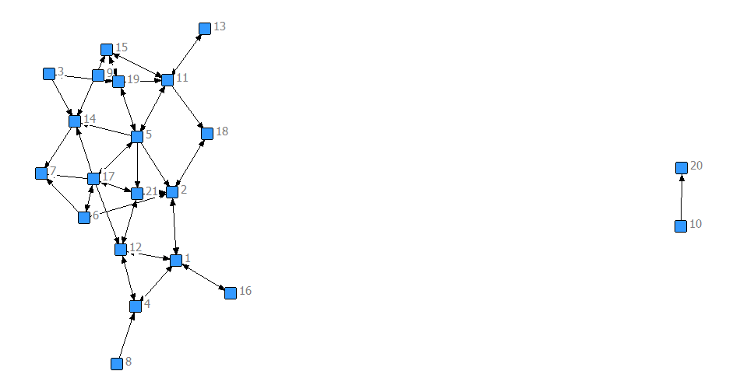

Actor #20:

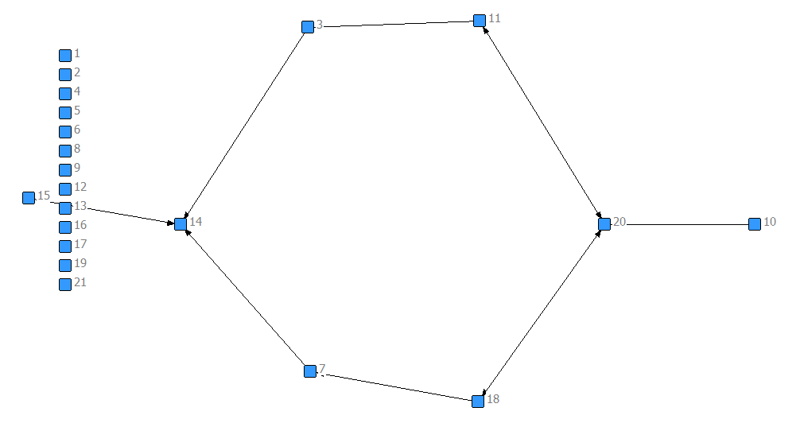

Actor #5:

